这个测试工程代码是使用windows 环境下的vs2022 开发，使用计算机的蓝牙来调试开发zerobase-windsor 固件代码的蓝牙ble 通讯，测试桑拿，高压氧舱，冷水浴缸，红外床的features id 功能, 注意: 该测试程序代码只是用来在固件开发过程中用来辅助调试zerobase-windsor固件，不是一个功能完善的，可以发布使用的软件!

his testing project code is developed using VS2022 in the Windows environment, using the computer's Bluetooth to debug and develop the Bluetooth BLE communication of the zerobase windsor firmware code. It tests the feature ID function of the sauna, hyperbaric oxygen chamber, cold water bathtub, and infrared bed.

Note: that this testing program code is only used to assist in debugging the zerobase windsor firmware during the firmware development process, and is not a fully functional software that can be released and used!

1. 使用vs2022 打开 BLE_MFCTest 目录下的BLE_MFCTest.sln 进行编译

Use vs2022 to open BLE-MFCTest.sln in the BLE-MFCTest directory for compilation

1. 执行BLE_MFCTest.exe 显示如下界面,点击 scan 按钮 搜寻以onebase 为名字的蓝牙设备，并在下面的显示框中显示搜索到的蓝牙设备，

Execute BLE-MFCTest.exe to display the following interface,

Click the scan button to search for Bluetooth devices named onebase, and display the searched Bluetooth devices in the display box below,

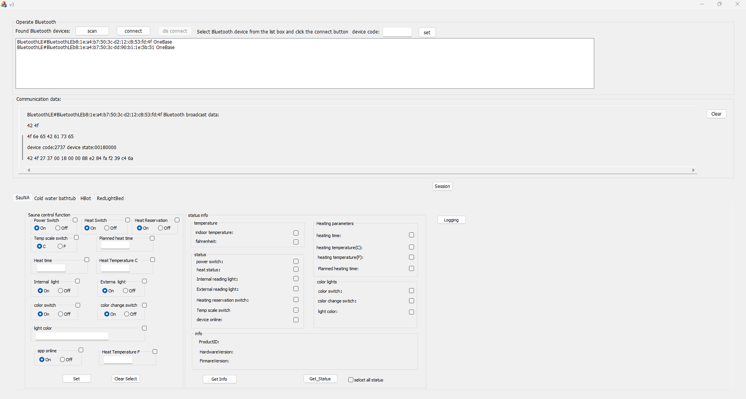

1. 在蓝牙设备列表框中选择一个蓝牙设备，点击connect 按钮进行连接，在communication data 显示框中会显示连接结果

Select a Bluetooth device from the Bluetooth device list box, click the connect button to connect, and the connection result will be displayed in the communication data display box

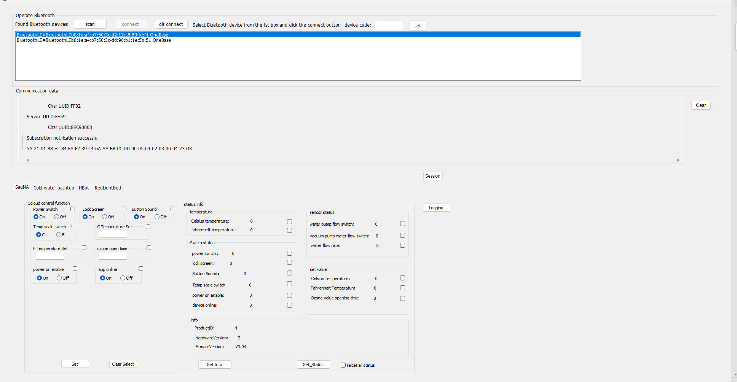

1. 针对一台没有写入设备码的设备，在device code 编辑框中输入设备代码，再点击set 按钮可以将设备码写入已经连接成功的蓝牙设备。

已经存在设备码的设备，点击连接后，测试程序会根据设备码选择进入该设备码对应的功能界面，例如上图，因为选择的蓝牙设备的设备码是冷水浴缸类型的设备，点击连接后进入了冷水浴缸的测试功能界面

For a device that has not been written with a device code, enter the device code in the device code editing box, and then click the set button to write the device code to the Bluetooth device that has been successfully connected.

For devices that already have a device code, after clicking connect, the testing program will select the corresponding function interface based on the device code, as shown in the above figure. Because the selected Bluetooth device has a device code of the cold water bathtub type, clicking connect will enter the testing function interface of the cold water bathtub

1. 在测试功能界面中，可以测试set ,get 两条指令的功能，

例如: 选择上power switch ,lock screen ,Temp scale switch 后面的 check box 后再点击

Set 按钮,设置程序会将这三个feature 的设置值发送給蓝牙设备

In the testing function interface, you can test the functionality of the set and get commands,For example, select the check box after the power switch, lock screen, and temperature scale switch, and then click Set button, the program will send the settings values of these three features to the Bluetooth device

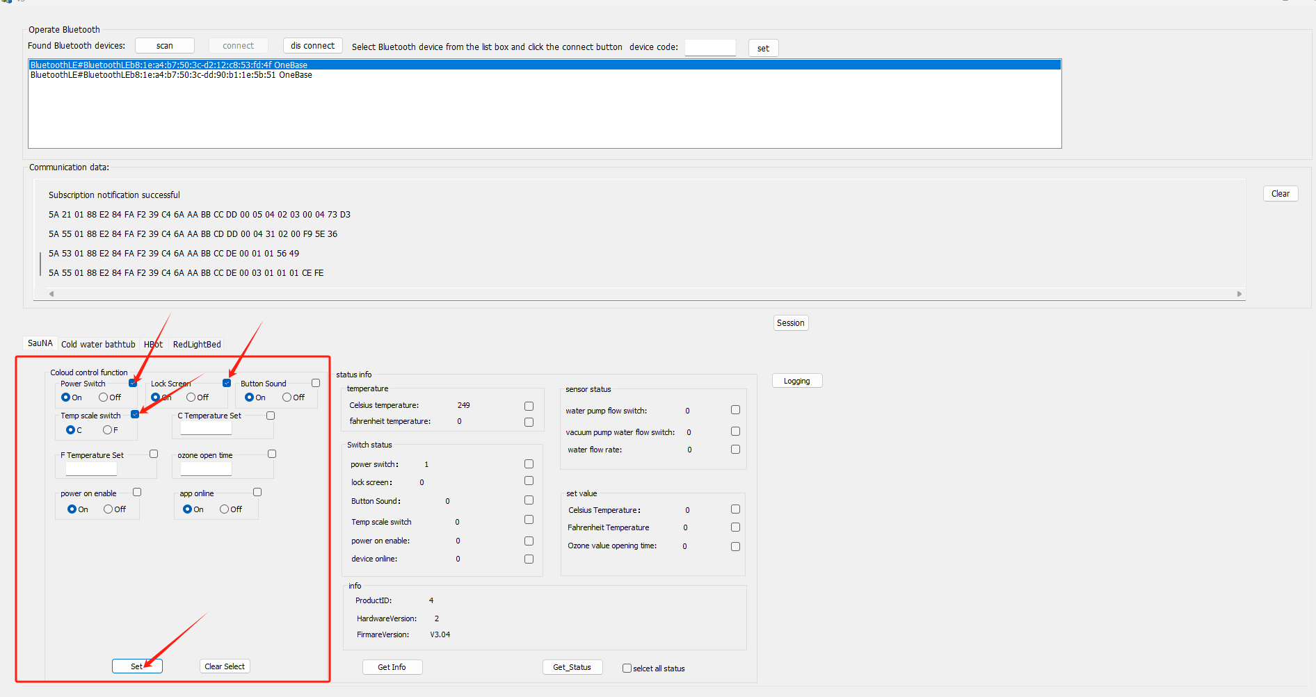

在 status info 下面，点击checkbox 选择上相应的状态features ,再点击Get Status按钮，会从蓝牙设备中读取相应的状态信息,如下图

Under the status info, click on the checkbox to select the corresponding status features, and then click the Get Status button. The corresponding status information will be read from the Bluetooth device, as shown in the following figure

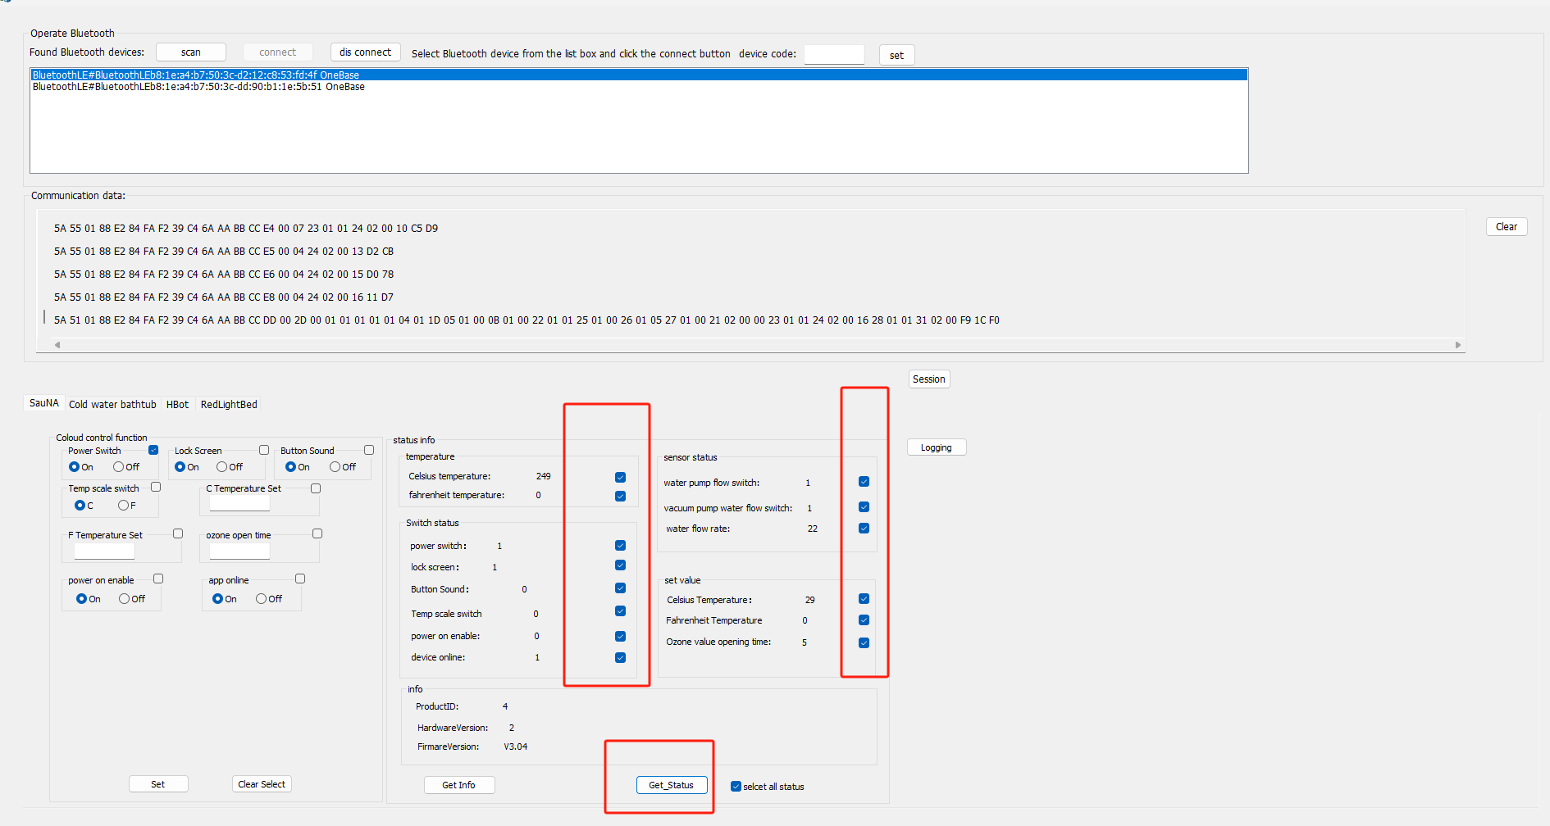

1. 点击session 按钮，会弹出session 窗口，测试session 功能

Click the session button to open the session window and test the session function

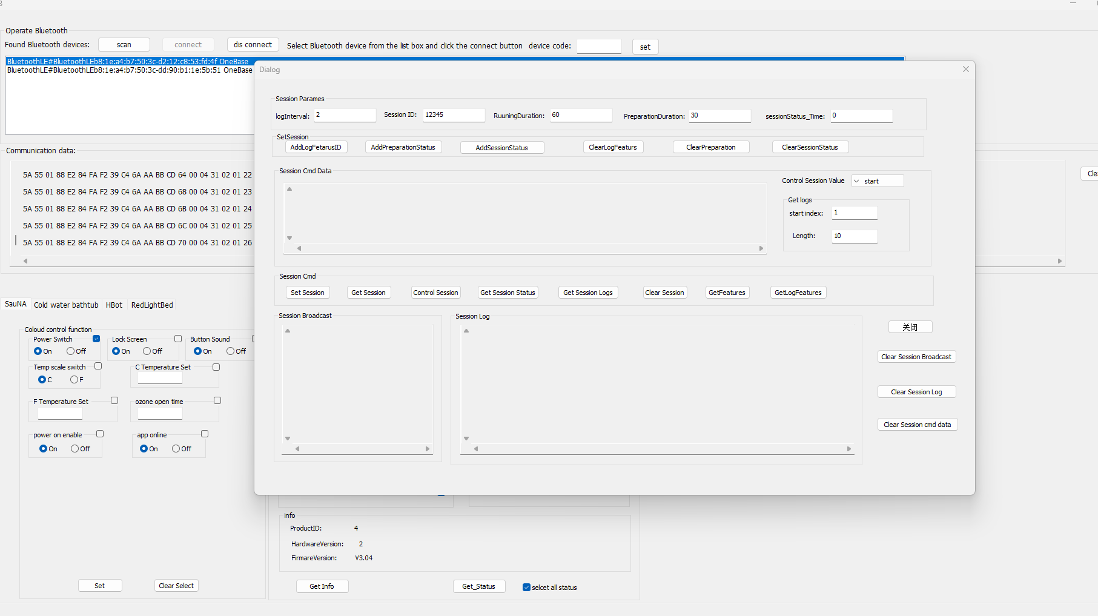

1. session窗口中的AddLogFeaturesID 功能中的features id 在主窗口中的status info中使用check box 进行选择.在主窗口中选择好以后，再点击AddLogFeatursID

The feature ID in the AddLogFeatures ID function in the session window can be selected using a checkbox in the status info section of the main window After selecting in the main window, click on Add Log Features ID

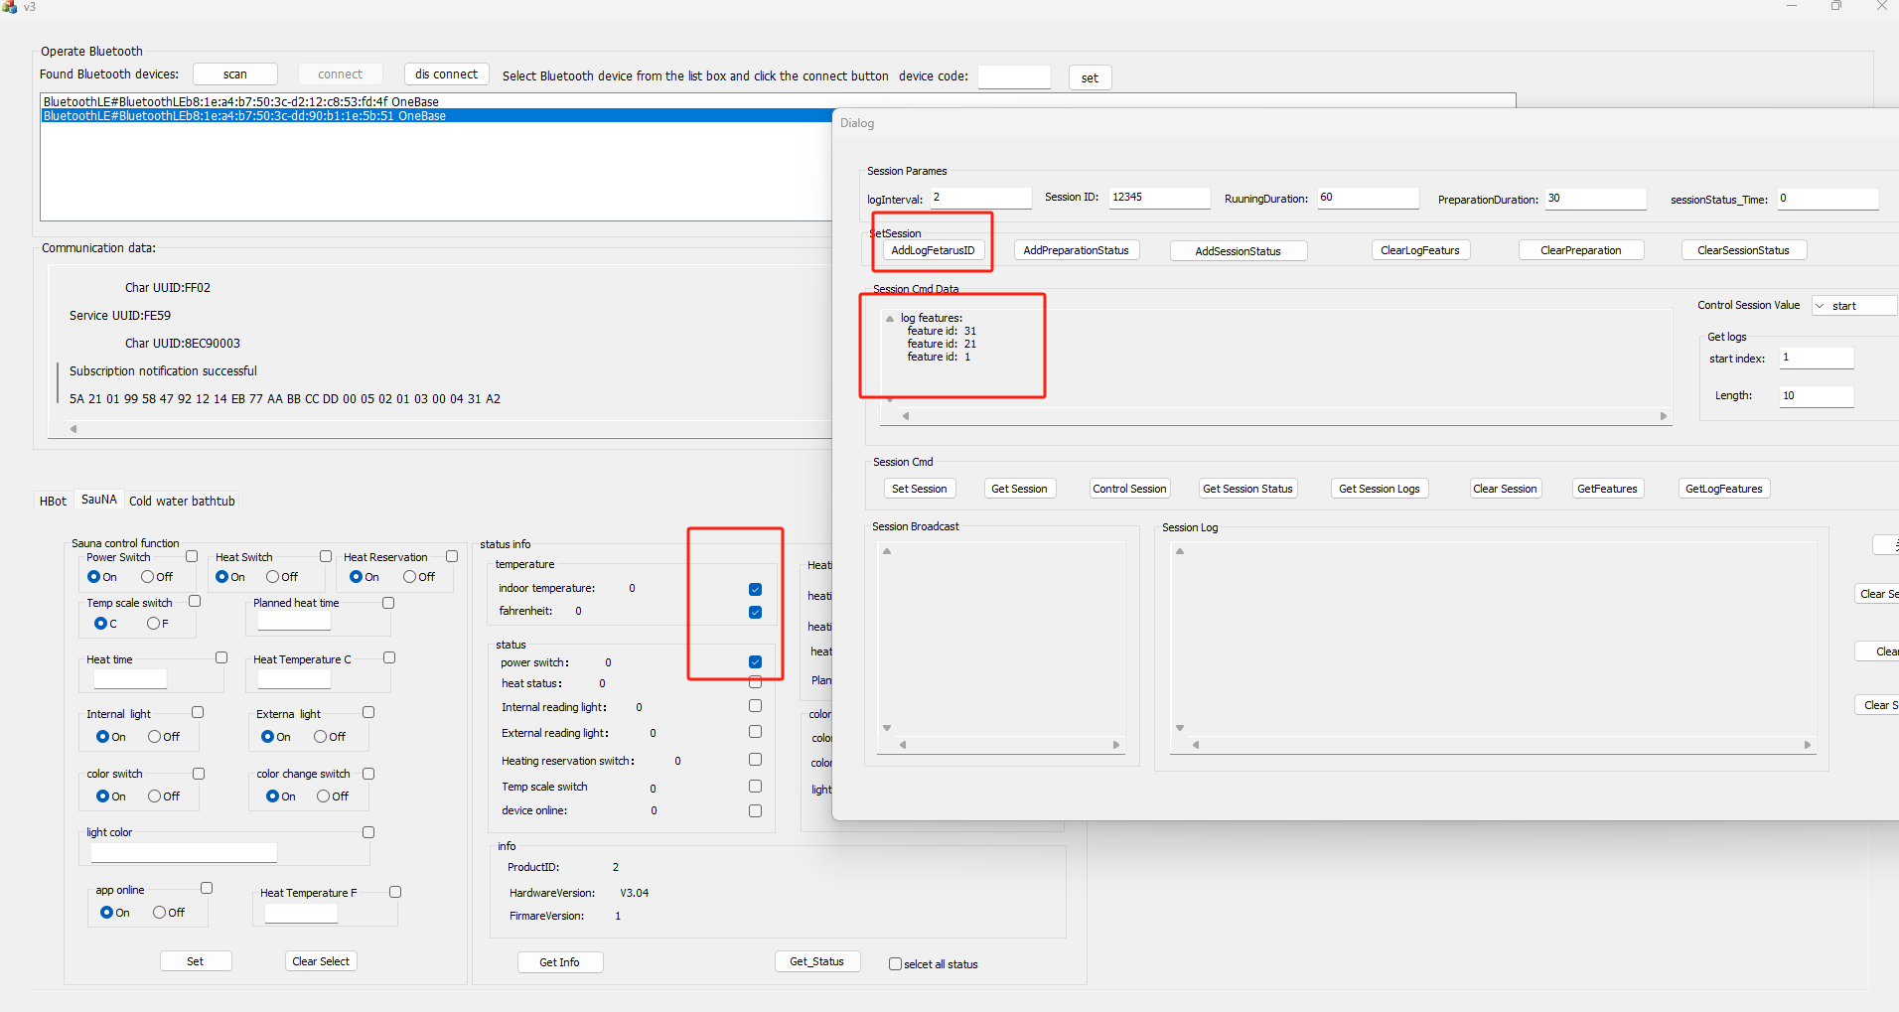

1. AddPreparationStatus 与AddSessionStatus 中的features 命令在 主窗口中的左边check box 中进行选择, 选择好以后再点击AddPreparationStatus 或者AddSessionStatus

Select the features command in the left check box of the main window between AddPreparationStatus and AddSessionStatus, and then click on AddPreparationStatus or AddSessionStatus after selecting them

